Assignment 4: Scaling to 100 million users

Assignment: You are tasked with designing an architecture that can support a user base of 100 million users. Discuss different ways to scale the architecture to meet this requirement, taking into consideration factors such as reliability, performance, and cost.

Some possible points to cover in your discussion:

1. Scaling horizontally: One approach to scaling is to add more servers or instances to the architecture. This is known as horizontal scaling and can be achieved using load balancers, auto-scaling groups, and containerization. Horizontal scaling is relatively easy to implement, but it requires careful management of resources to ensure that the architecture can handle increased traffic and maintain performance.
2. Scaling vertically: Another approach to scaling is to increase the size or power of the servers or instances in the architecture. This is known as vertical scaling and can be achieved by upgrading hardware components such as processors, memory, or storage. Vertical scaling can be more challenging to implement than horizontal scaling, but it can provide a more cost-effective solution for architectures with high resource requirements.
3. Distributed architecture: A distributed architecture involves breaking down the architecture into smaller, independent components that can be deployed across multiple servers or data centers. This approach can improve performance and reliability by reducing the impact of failures in individual components. Distributed architectures can be complex to design and manage, but they offer a scalable and flexible solution for handling large user bases.
4. Cloud-based solutions: Cloud platforms such as AWS, Azure, and GCP offer a range of services that can be used to scale architectures. These include serverless computing, managed databases, and content delivery networks. Cloud-based solutions can be more cost-effective than traditional architectures, and they offer a high level of scalability and flexibility.
5. Caching: Caching involves storing frequently accessed data in memory or on fast storage devices to improve performance. Caching can be implemented at various levels of the architecture, including application caching, database caching, and CDN caching. Caching can significantly reduce the load on backend servers and improve response times, making it a key component of a scalable architecture.

Discuss these different ways to scale and how they can be combined to create a scalable architecture that can support a user base of 100 million users. Provide examples of real-world architectures that have successfully scaled to large user bases, and highlight the benefits and trade-offs of different scaling approaches.

# Solution:

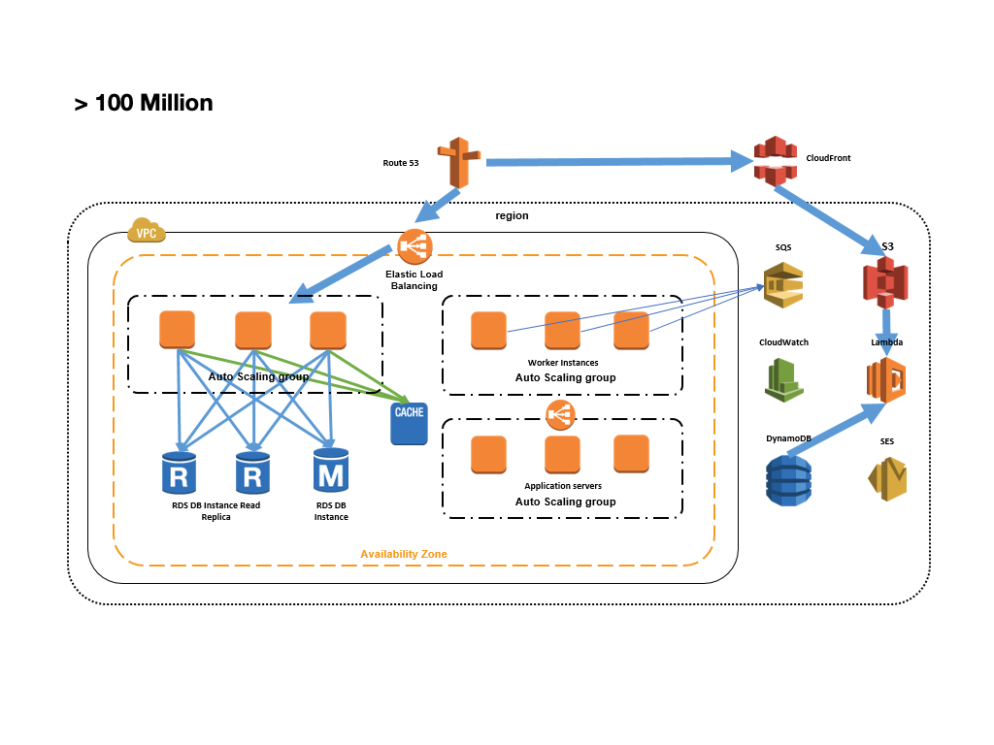

Deploying across multiple Availability Zones

Using Elastic Load Balancing (ELB) between tiers

Using Auto Scaling

Using service-oriented architecture

Serving content using appropriate AWS services (for example, local vs. Elastic Block Store vs. S3)

Caching off DB using ElastiCache

Moving state off tiers so you can horizontally scale

Database Federation

Data Warehouse

MDM Strategy

To scale an architecture to support 100 million users, architects need to consider multiple factors such as reliability, performance, and cost. Below are different ways to scale and the considerations for each approach:

## Horizontal scaling:

This approach involves adding more servers or instances to the architecture. Horizontal scaling can be achieved using load balancers, auto-scaling groups, and containerization. This approach provides a cost-effective way to scale, as resources can be added incrementally as needed. However, architects need to manage resource allocation carefully to avoid performance issues and optimize cost.

Considerations for horizontal scaling:

* Load balancing: Implementing load balancing ensures that requests are distributed evenly across multiple servers, improving performance and reliability. The architecture should also use elastic load balancing to automatically add or remove servers based on traffic demands.
* Auto-scaling: Auto-scaling groups can automatically add or remove servers based on predefined thresholds, such as CPU utilization or network traffic. This ensures that the architecture can scale up or down as needed, providing efficient resource allocation and minimizing costs.
* Containerization: Containerization provides a lightweight way to isolate applications and services, making it easier to deploy and scale. Container orchestration tools such as Kubernetes can be used to manage containerized workloads and scale them horizontally.

## Vertical scaling:

This approach involves increasing the size or power of the servers or instances in the architecture. Vertical scaling can be achieved by upgrading hardware components such as processors, memory, or storage. This approach provides a cost-effective solution for architectures with high resource requirements, but it can be challenging to implement.

Considerations for vertical scaling:

* Hardware upgrades: Upgrading hardware components such as processors, memory, or storage can improve the performance and capacity of the architecture. However, architects need to ensure that the upgraded components are compatible with the existing architecture and that they provide a significant performance boost.
* Serverless computing: Serverless computing platforms such as AWS Lambda provide a scalable and cost-effective way to run applications and services without managing servers. This approach allows for scaling without worrying about the underlying infrastructure and can be useful for specific use cases.

1. Distributed architecture:

This approach involves breaking down the architecture into smaller, independent components that can be deployed across multiple servers or data centers. A distributed architecture can improve performance and reliability by reducing the impact of failures in individual components. However, it can be complex to design and manage.

## Considerations for distributed architecture:

* Microservices: Microservices architecture breaks down the application into smaller, independent components that can be deployed and scaled independently. This approach can improve performance and reliability by isolating failures and reducing the impact of changes. However, it requires careful management of the inter-component dependencies and communication.
* Multi-region deployment: Deploying the architecture across multiple regions can provide high availability and performance. However, it requires careful consideration of the data replication and synchronization, as well as the latency between regions.

1. Cloud-based solutions:

Cloud platforms such as AWS, Azure, and GCP offer a range of services that can be used to scale architectures. These include serverless computing, managed databases, and content delivery networks. Cloud-based solutions can be more cost-effective than traditional architectures, and they offer a high level of scalability and flexibility.

## Considerations for cloud-based solutions:

* Managed services: Cloud providers offer managed services for databases, messaging, caching, and other components. These services can reduce the complexity and cost of managing the infrastructure and provide a scalable and reliable solution.
* Content delivery network: A content delivery network (CDN) can improve the performance and availability of static content by caching it on servers distributed around the world. This approach can reduce the load on the origin servers and help distribute the traffic across multiple servers. Another way to scale is to use a Content Delivery Network (CDN). A CDN is a network of servers distributed across the globe that caches and delivers content to users based on their geographic location.

To further scale to 100 million users, another approach is to implement load balancing. Load balancing distributes incoming network traffic across multiple servers to ensure that no single server is overwhelmed. This can be achieved using hardware or software load balancers.

Another way to scale is by implementing auto scaling. Auto scaling is a technique used to automatically adjust the number of servers based on the current traffic load. This can be done by setting up thresholds and triggers that will automatically increase or decrease the number of servers as needed.

In addition, implementing microservices architecture can also help to scale the application. Microservices architecture breaks down the application into small, independent services that can be developed, deployed, and scaled independently. This allows for better resource utilization and improved scalability.

Finally, leveraging serverless computing can also help to scale the application. Serverless computing allows developers to write and deploy code without having to worry about the underlying infrastructure. The cloud provider takes care of the scaling and resource allocation. This can lead to cost savings and improved scalability.

Overall, scaling to 100 million users requires a combination of techniques and approaches. By implementing a well-architected framework and considering factors such as load balancing, auto scaling, microservices, and serverless computing, architects can ensure that their application can handle the scale and demands of a large user base.